|  |  |
| --- | --- |
| File:COMSATS new logo.jpg - Wikimedia Commons  Programming Fundamentals  Lab-5 | **submitted by:**  **Shahzaneer Ahmed**  **registration number:**  **sp21-bcs-087**  **submitted to:**  **Mr. rizwan rashid**  **date of submission:**  **October 19, 2021** |

Activity 01

# Source Code :

//Shahzaneer Ahmed

//SP21-BCS-087

//LAB 04

//Activity-1

// Consider the statements:

// double x = 75.3987;

// double y = 982.89764;

// What is the output of the following statements?

// a. System.out.printf("%.2f %n", x);

// b. System.out.printf("%.2f %n", y);

// c. System.out.printf("%.3f %n", x);

// d. System.out.printf("%.3f %n", y)

public class Activity1 {

public static void main(String[] yahan_kuch_bhi_asakta_Hai) {

double x = 75.3987;

double y = 982.89764;

System.out.printf("%.2f %n" , x); //f is used for formatting %n is for for new line

// field is less important , it only works when it is given more than the digits given.

System.out.printf("%.2f %n" , y); // 982.90 it also rounds off the number

System.out.printf("%.3f %n" , x); //75.399

System.out.printf("%.3f %n" , y); //982.898

}

}

Screenshot :

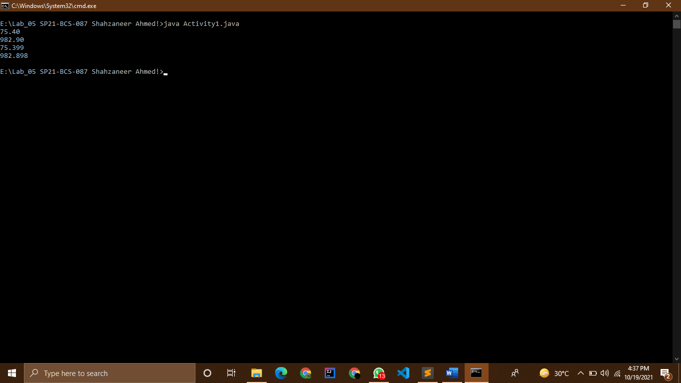

Activity 02

# Source Code :

//Shahzaneer Ahmed

//SP21-BCS-087

//LAB 04

//Activity-2

// Show the output of the following statements.

// a. System.out.printf("amount is %f %e\n", 32.32, 32.32);

// b. System.out.printf("amount is %5.2%% %5.4e\n", 32.327, 32.32);

// c. System.out.printf("%6b\n", (1 > 2));

// d. System.out.printf("%6s\n", "Java");

// e. System.out.printf("%-6b%s\n",(1 > 2), "Java");

// f. System.out.printf("%6b%-8s\n",(1 > 2), "Java");

public class Activity2 {

public static void main(String[] args) {

System.out.printf("amount is %f %e\n",32.32 , 32.32);

// amount is 32.320000 3.232000e+01

// Notice these answers are only true when using System.out.printf() or

// System.out.format() or the Formatter object.

// If you use %n in System.out.println(), it will simply produce

// a %n, not a newline.

System.out.printf("amount is %5.2f %5.4e\n", 32.327, 32.32);

// amount is 32.33 3.2320e+01

System.out.printf("%6b\n",(1 > 2)); // false with one space to the left

System.out.printf("%6s\n", "Java"); // java two spaces on left

System.out.printf("%-6b%s\n",(1 > 2), "Java"); // false Java

System.out.printf("%6b%-8s\n",(1 > 2), "Java"); // falseJava

}

}

Screenshot :

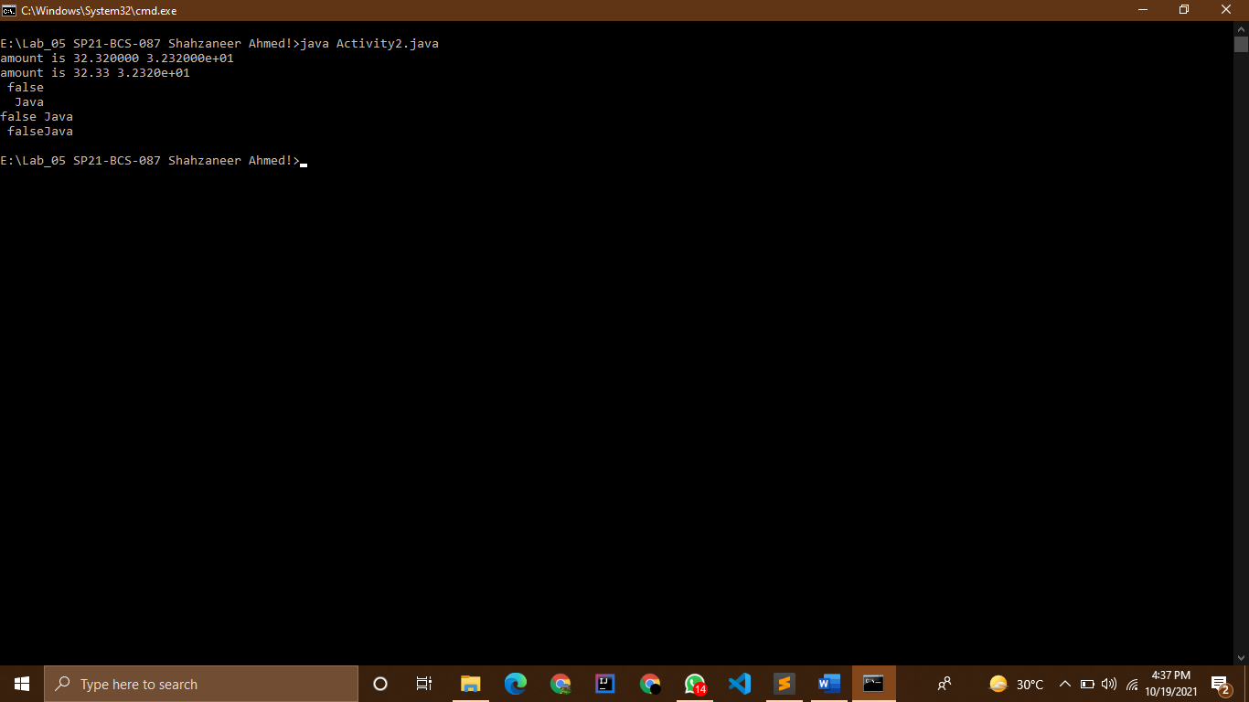

Activity 03

# Source Code :

//Shahzaneer Ahmed

//SP21-BCS-087

//LAB 04

//Activity-3

// What is wrong in the following statements?

// a. System.out.printf("%5d %d", 1, 2, 3);

// b. System.out.printf("%5d %f", 1);

// c. System.out.printf("%5d %f", 1, 2);

public class Activity3 {

public static void main(String[] args) {

System.out.printf("%5d %d", 1, 2, 3); // 5 spaces 1 1space 3 is ignored as it isn't used.

// System.out.printf("%5d %f", 1); //Exception in thread "main" java.util.MissingFormatArgumentException: Format specifier '%f'

// %f is unnecessary used.

// System.out.printf("%5d %f", 1, 2); //invalid argument of formatted specifiers

// Exception in thread "main" java.util.IllegalFormatConversionException: f != java.lang.Integer

}

}

Screenshot :

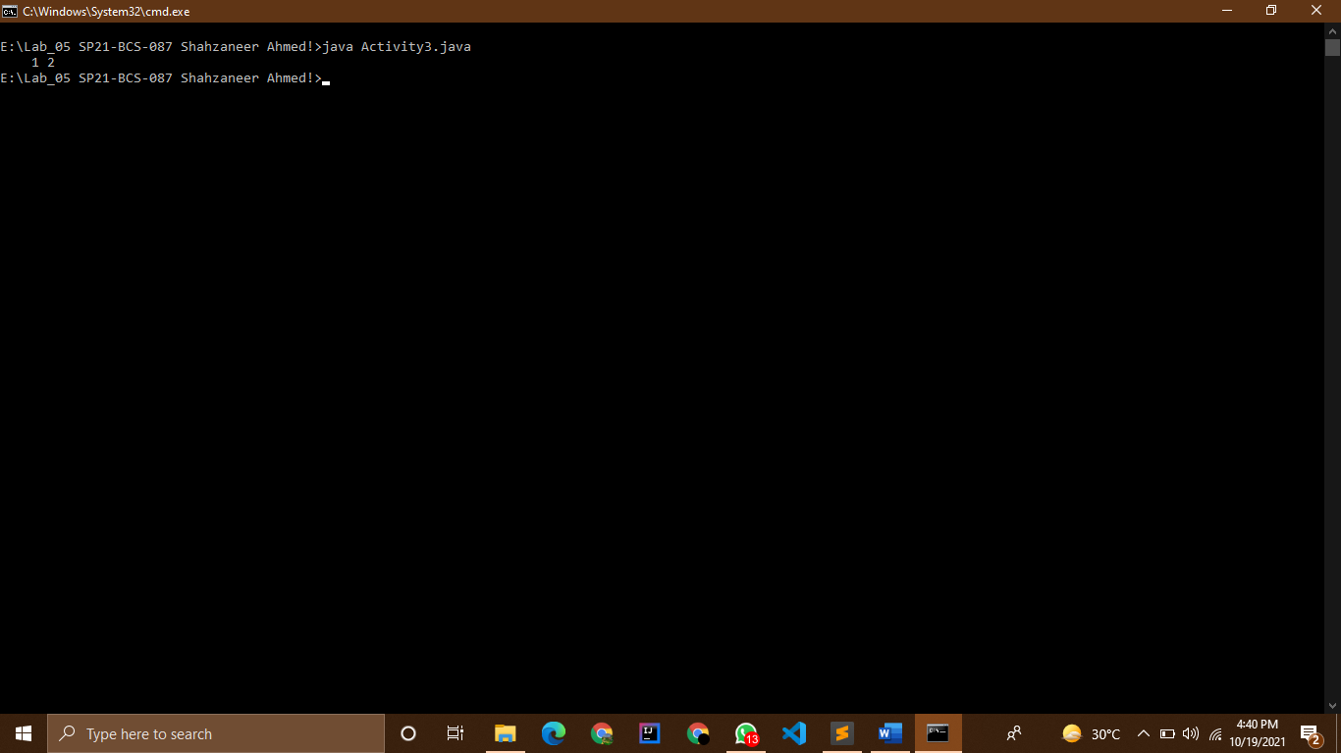

Activity 04

# Source Code :

//Shahzaneer Ahmed

//SP21-BCS-087

//LAB 04

//Activity-4

// Write JAVA statements using System.out.prinf() statement to display output as given

// below

//public class DemoFormat {

// public static void main(String[] args) {

// // Display the header of the table using System.out.printf()

// int degrees = 30;

// double radians = Math.toRadians(degrees);

// double sin = Math.sin(radians);

// double cos = Math.cos(radians);

// double tan = Math.tan(radians);

// // Display the Data of the table using System.out.printf()

//

// degrees = 60;

// radians = Math.toRadians(degrees);

// sin = Math.sin(radians);

// cos = Math.cos(radians);

// tan = Math.tan(radians);

// // Display the Data of the table using System.out.printf()

// }

//}

// Degrees Radians Sine Cosine Tangent

// 30 0.5236 0.5000 0.8660 0.5773

// 60 1.0472 0.8660 0.5000 1.732

import java.math.*;

public class Activity4 {

public static void main(String[] args) {

// Display the header of the table using System.out.printf()

int degrees = 30;

double radians = Math.toRadians(degrees);

double sin = Math.sin(radians);

double cos = Math.cos(radians);

double tan = Math.tan(radians);

// Display the Data of the table using System.out.printf()

int _degrees = 60;

double _radians = Math.toRadians(degrees);

double _sin = Math.sin(radians);

double _cos = Math.cos(radians);

double _tan = Math.tan(radians);

// Display the Data of the table using System.out.printf()

System.out.println("Degrees Radians Sine Cosine Tangent");

System.out.printf("%-5d %6.4f %6.4f %6.4f %6.4f \n",degrees,radians,sin,cos,tan);

System.out.printf("%-5d %6.4f %6.4f %6.4f %6.4f ",_degrees,_radians,_sin,_cos,_tan);

// Degrees Radians Sine Cosine Tangent

// 30 0.5236 0.5000 0.8660 0.5774

// 60 0.5236 0.5000 0.8660 0.5774

}

}

Screenshot :

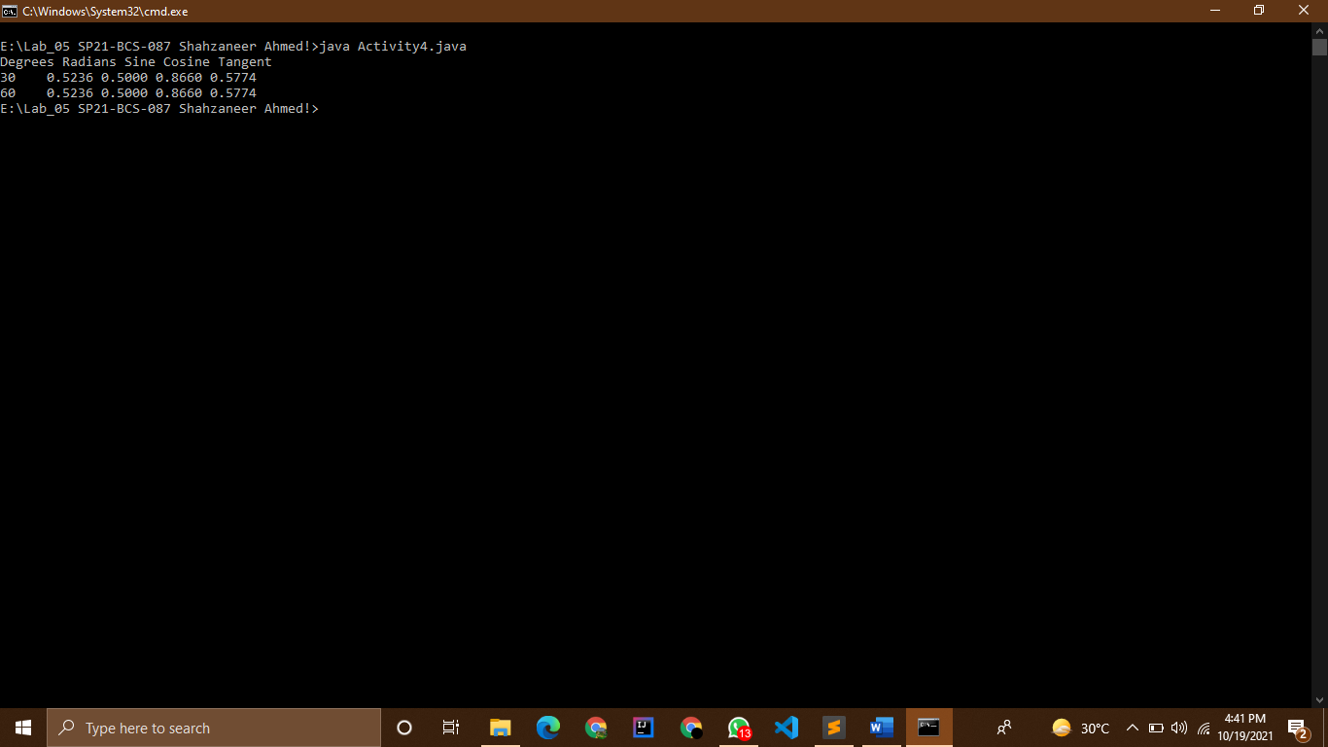

Activity 05

# Source Code :

//Shahzaneer Ahmed

//SP21-BCS-087

//LAB 04

//Relational Operators; Logical Operators; Boolean Data Type;

// Activity-5

// Suppose that x, y, and z are int variables and x = 10 , y = 15 , and z = 2 0. Determine

// whether the following expressions evaluates to true or false .

// a. !(x > 1 0)

// b. x <= 5 || y < 15

// c. (x != 5 ) && (y != z)

// d. x >= z || (x + y >= z)

// e. (x <= y – 2) && (y >= z) || (z – 2 != 20)

public class Activity5 {

public static void main(String[] args) {

int x,y,z;

x =10;

y =15;

z =20;

System.out.println(x>10); //False

System.out.println((x <= 5) || (y < 5)); // false

System.out.println((x!=5) && (y!=z)); //True

System.out.println( (x >= z) || (x + y >= z)); //True

boolean s1 = (x <= (y-2));

boolean s2 = (y >= z);

int d = ((z-2));

boolean s3 = (d!=20);

System.out.println(s1 && s2 || s3); //false

// System.out.println((x <= (y – 2)) && (y >= z)) || ((z – 2) != 20);

}

}

Screenshot :

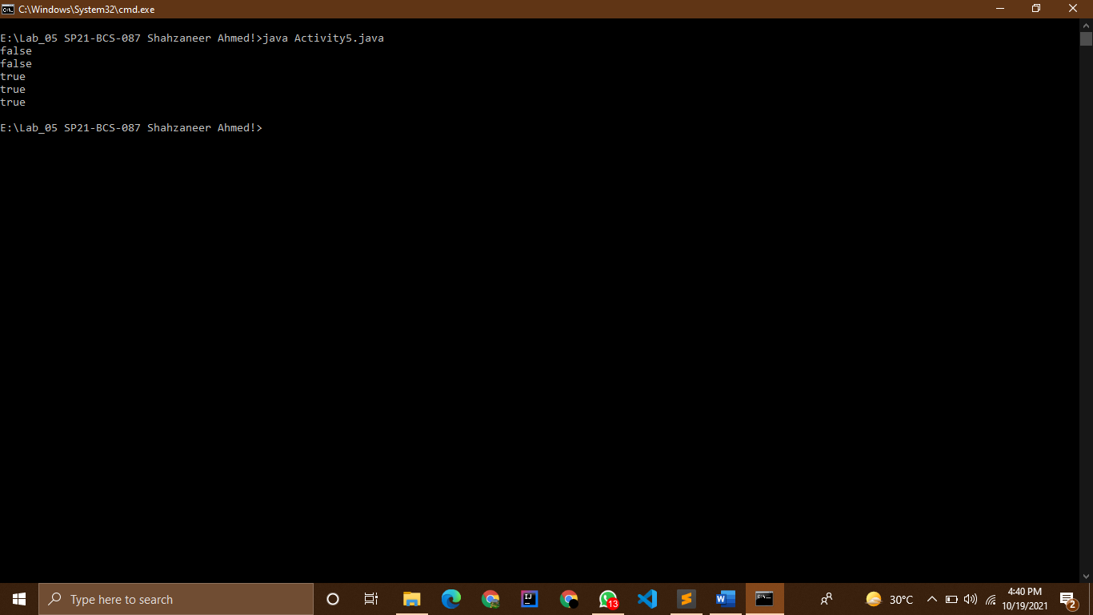

Activity 06

# Source Code :

//Shahzaneer Ahmed

//SP21-BCS-087

//LAB 04

//Activity-6

// Suppose that x, y, z,and w are int variables and x = 3, y = 4, z = 7,and w =1. What is the

// output of the following statements?

// a. System.out.println("x == y: " + (x == y ));

// b. System.out.println("x != z: " + (x != z ));

// c. System.out.println("y == z – 3: " + (y == z – 3) );

// d. System.out.println("!(z > w): " + ! (z > w));

// e. System.out.println("x + y < z: " + (x + y < z));

public class Activity6 {

public static void main(String[] args) {

int x,y,z,w;

x = 3;

y = 4;

z = 7;

w = 1;

System.out.println("x == y: " + (x == y )); // false //x == y: false

System.out.println("x != z: " + (x != z )); //true // x != z: true

int i = z-3;

System.out.println("y == z – 3: " + (y == i)); //true //y == z – 3: true

System.out.println("!(z > w): " + ! (z > w));// false //!(z > w): false

System.out.println("x + y < z: " + (x + y < z)); //false // x + y < z: false

}

}

Screenshot :

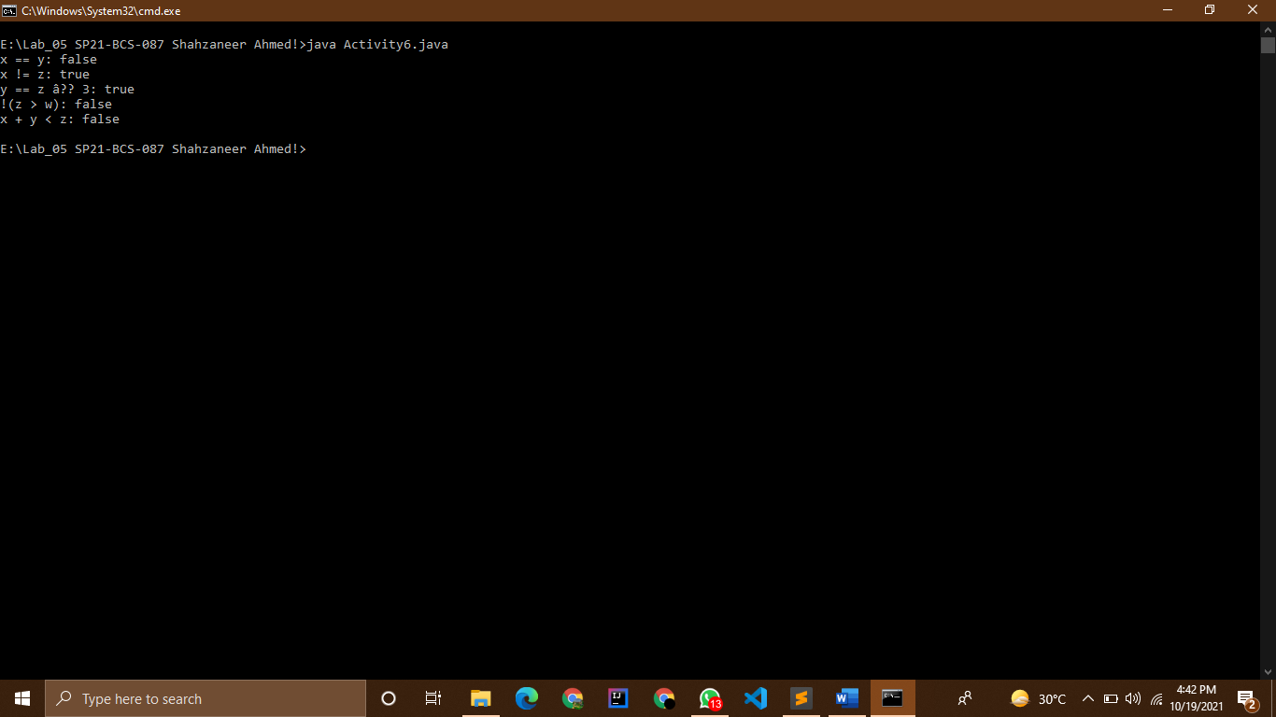

Activity 07

# Source Code :

//Shahzaneer Ahmed

//SP21-BCS-087

//LAB 04

//Activity 07

//Consider the following code segment. Determine the value of b3

// boolean b1=true;

// boolean b2=false;

// boolean b3=(b1==b2)

public class Activity7 {

public static void main(String[] args) {

boolean b1=true;

boolean b2=false;

boolean b3=(b1==b2);

System.out.println(b3); //faslse

}

}

Screenshot :

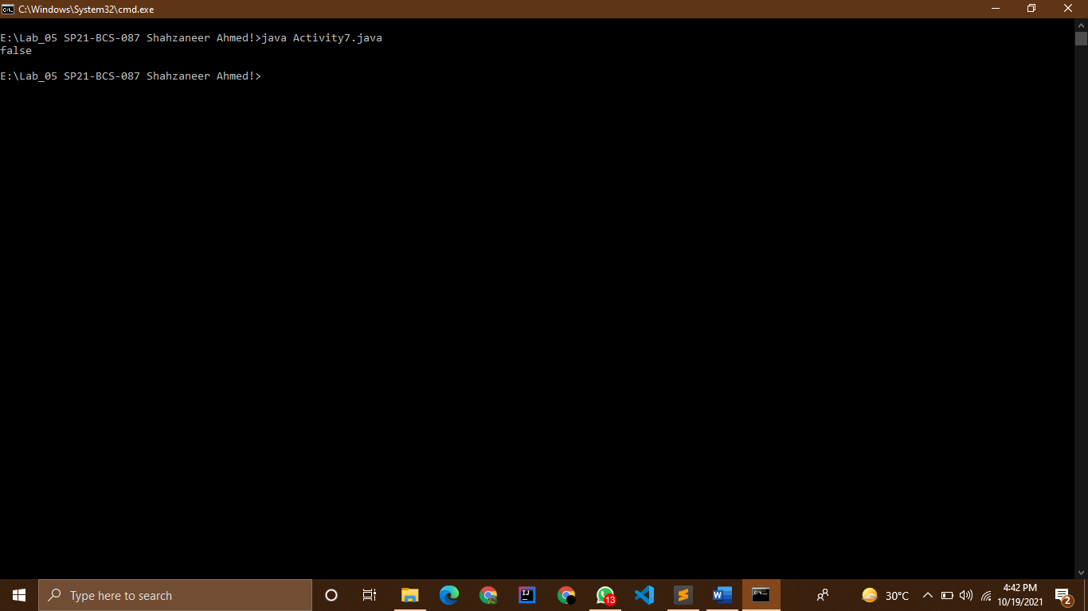

Activity 08

# Source Code :

//Shahzaneer Ahmed

//SP21-BCS-087

//LAB 04

//One-Way If Statement; Two-Way If Statement; Nested If Statement; Multi-way If

// Statement; Conditional Operators; Switch Statement

// Activity-8

// Minimum of two numbers: Given two integers, print the smaller value.

public class Activity8 {

public static void main(String[] args) {

int num1 = 4;

int num2 = 6;

if (num1 > num2) System.out.println(num1);

else System.out.println(num2);

}

}

Screenshot :

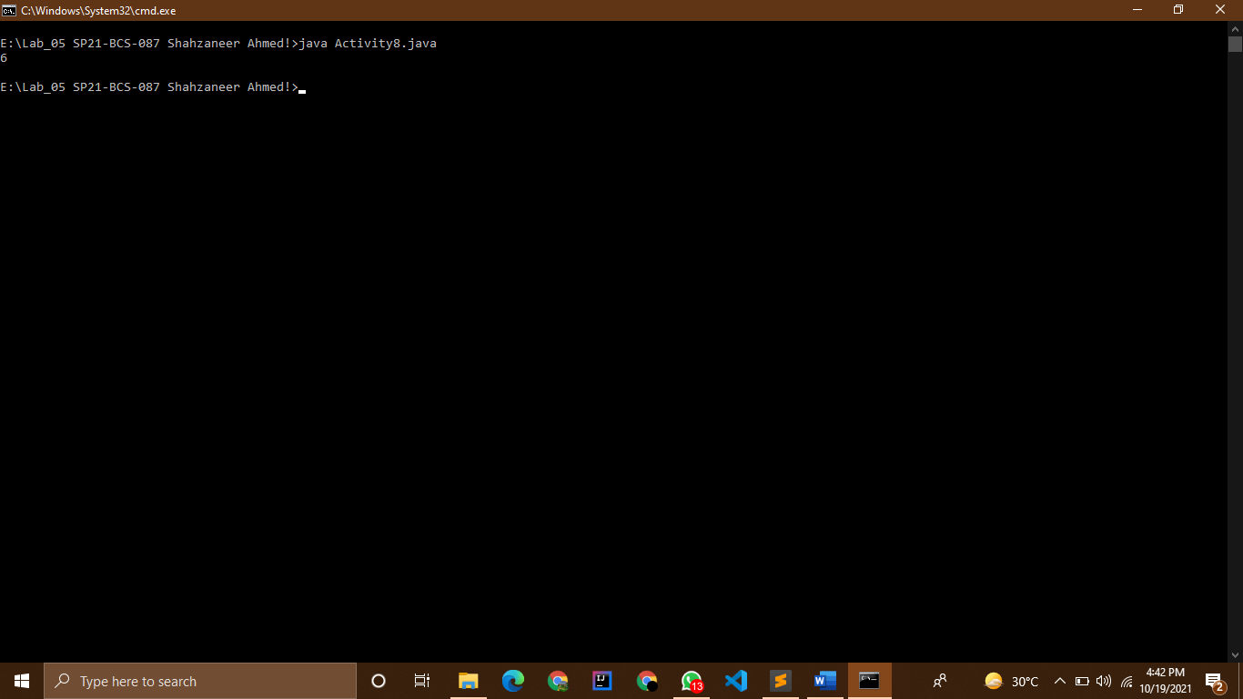

Activity 09

# Source Code :

//Shahzaneer Ahmed

//SP21-BCS-087

//LAB 04

//Activity-9

// Sign function: For the given integer X print 1 if it's positive, -1 if it's negative, or 0 if it's

// equal to zero.

import java.util.Scanner;

public class Activity9 {

public static void main(String[] args) {

Scanner obj = new Scanner(System.in);

System.out.println("Enter Any Integer :");

int integer = obj.nextInt();

if (integer>0) System.out.println("+1");

else if (integer<0) System.out.println("-1");

else System.out.println(0);

}

}

Screenshot :

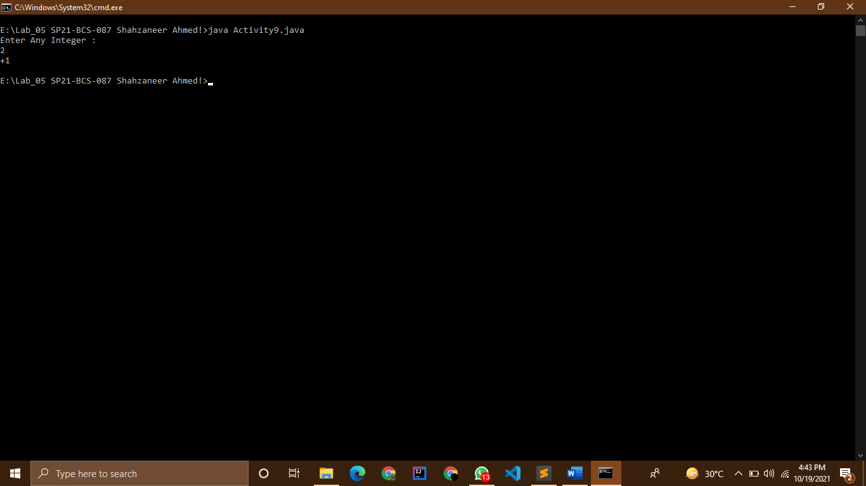

Activity 10

# Source Code :

//Shahzaneer Ahmed

//SP21-BCS-087

//LAB 04

//Activity-10

// Minimum of three numbers: Given three integers, print the smallest value

import java.util.Scanner;

public class Activity10 {

public static void main(String[] args) {

Scanner obj = new Scanner(System.in);

System.out.println("Enter three integers");

int integer1 = obj.nextInt();

int integer2 = obj.nextInt();

int integer3 = obj.nextInt();

if (integer1<integer2 && integer1<integer3) System.out.println("The smallest number is :"+integer1);

if (integer2<integer1 && integer2<integer3) System.out.println("The smallest number is :"+integer2);

if (integer3<integer2 && integer3<integer1) System.out.println("The smallest number is :"+integer3);

}

}

Screenshot :

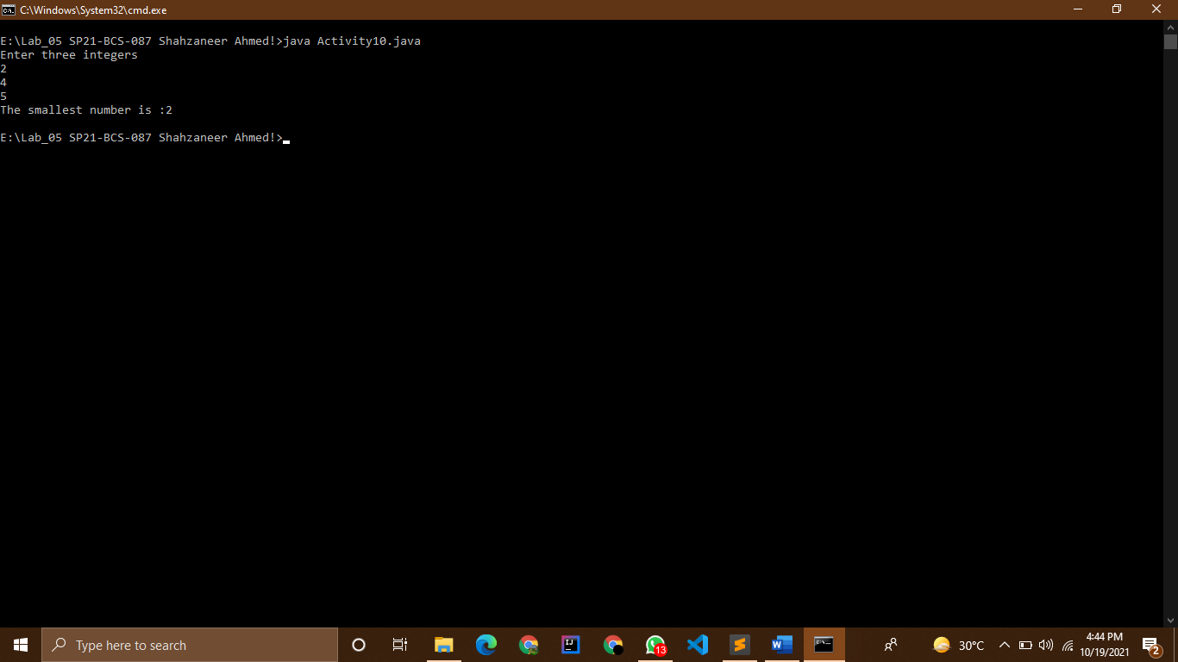

Activity 11

# Source Code :

//Shahzaneer Ahmed

//SP21-BCS-087

//LAB 04

//Activity-11

// Equal numbers: Given three integers, determine how many of them are equal to each

// other. The program must print one of these numbers: 3 (if all are the same), 2 (if two of

// them are equal to each other and the third is different) or 0 (if all numbers are different).

// Sample Input: 10 5 10 Output: 2

import java.util.Scanner;

public class Activity11 {

public static void main(String[] args) {

Scanner obj = new Scanner(System.in);

System.out.println("Enter 1st integer");

int integer1 = obj.nextInt();

System.out.println("Enter 2nd integer");

int integer2 = obj.nextInt();

System.out.println("Enter 3rd integer");

int integer3 = obj.nextInt();

if (integer1==integer2 && integer2==integer3){

// if three integers are euqal to each other

System.out.println(3);

}

else if (integer1==integer2 || integer2==integer3 || integer1==integer3){

// if only two integer are equal to each other

System.out.println(2);

}

// if no integer is equal to each other

else System.out.println("NO same Integer");

}

}

Screenshot :

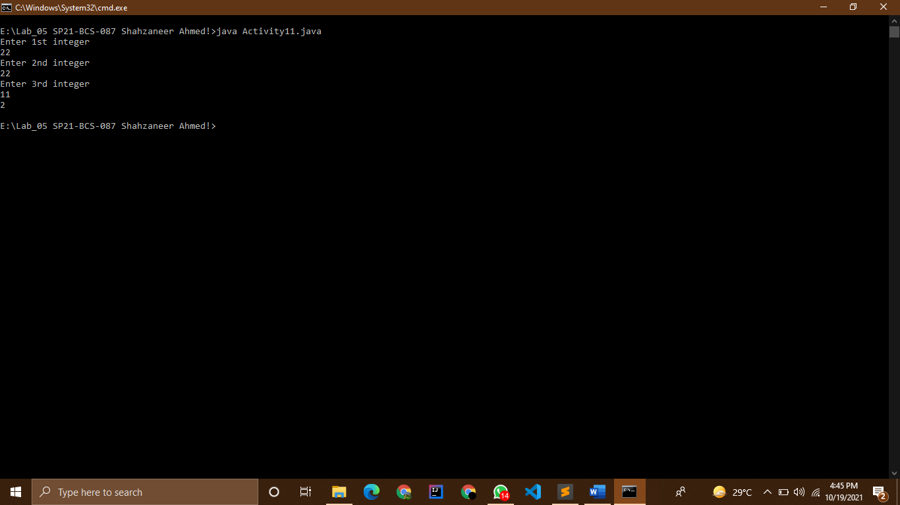

Activity 12

# Source Code :

//Shahzaneer Ahmed

//SP21-BCS-087

//LAB 04

//Activity-12

// Roman Numerals

// Write a program that prompts the user to enter a number within the range of 1 through

// 10. The program should display the Roman numeral version of that number. If the

// number is outside the range of 1 through 10, the program should display an error

// message. The following table shows the Roman numerals for the numbers 1 through 10

import java.util.Scanner;

public class Activity12 {

public static void main(String[] args) {

Scanner obj = new Scanner(System.in);

System.out.println("Enter any number between 1 to 10 ");

int num = obj.nextInt();

if (num>0 && num<=10){

if (num == 1) System.out.println("I");

if (num == 2) System.out.println("II");

if (num == 3) System.out.println("III");

if (num == 4) System.out.println("IV");

if (num == 5) System.out.println("V");

if (num == 6) System.out.println("VI");

if (num == 7) System.out.println("VII");

if (num == 8) System.out.println("VIII");

if (num == 9) System.out.println("IX");

if (num == 10) System.out.println("X");

}

else System.out.println("Error!! please Enter any number only in between 1 and 10 ");

}

}

Screenshot :

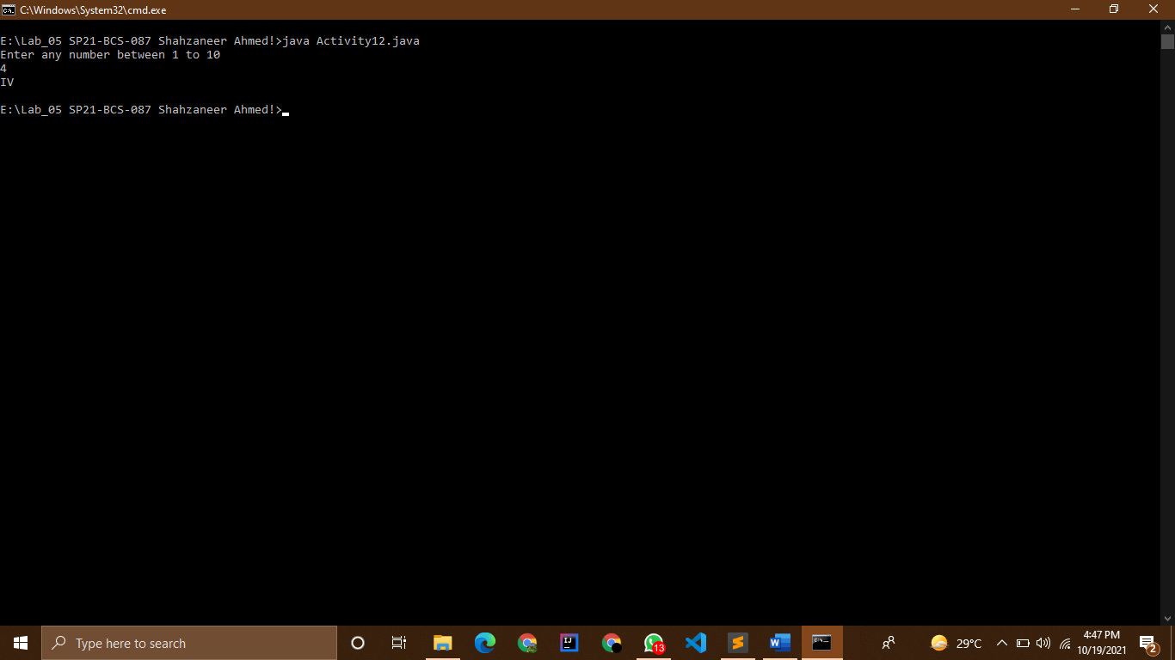

Activity 13

# Source Code :

//Shahzaneer Ahmed

//SP21-BCS-087

//LAB 04

//Activity-13

// Areas of Rectangles

// The area of a rectangle is the rectangle’s length times its width. Write a program that

// asks for the length and width of two rectangles. The program should tell the user which

// rectangle has the greater area, or if the areas are the same.

import java.util.Scanner;

public class Activity13 {

public static void main(String[] args) {

Scanner obj = new Scanner(System.in);

System.out.println("Enter the Length of 1st Rectangle :");

double len1 = obj.nextDouble();

System.out.println("Enter the width of 1st Rectangle :");

double wid1 = obj.nextDouble();

System.out.println("Enter the Length of 2nd Rectangle :");

double len2 = obj.nextDouble();

System.out.println("Enter the width of 2nd Rectangle :");

double wid2 = obj.nextDouble();

double areaFirstRectangle = len1*wid1;

double areaSecondRectangle = len2*wid2;

if (areaFirstRectangle>areaSecondRectangle) System.out.println("The first Rectangle has greater area that is " +areaFirstRectangle +" Units");

if (areaFirstRectangle<areaSecondRectangle) System.out.println("The Second Rectangle has greater area that is" +

" " +areaSecondRectangle +" Units");

if (areaFirstRectangle==areaSecondRectangle) System.out.println("Both Rectangles have equal Areas i.e. " +

" " +areaSecondRectangle +" Units each ");

}

}

Screenshot :

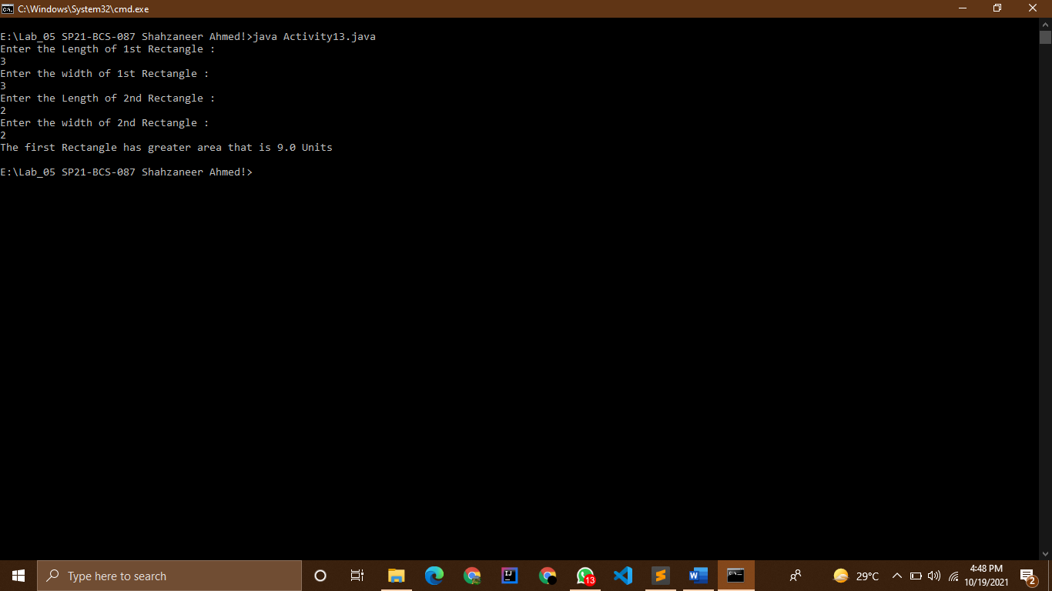

Activity 14

# Source Code :

//Shahzaneer Ahmed

//SP21-BCS-087

//LAB 04

//Activity-14

// Mass and Weight

// Scientists measure an object’s mass in kilograms and its weight in newtons. If you know

// the amount of mass of an object in kilograms, you can calculate its weight in newtons

// with the following formula:

// weight = mass x 9.8

// Write a program that asks the user to enter an object’s mass, and then calculates its

// weight. If the object weighs more than 1,000 newtons, display a message indicating that

// it is too heavy. If the object weighs less than 10 newtons, display a message indicating

// that it is too light.

import java.util.Scanner;

public class Activity14 {

public static void main(String[] args) {

Scanner obj = new Scanner(System.in);

System.out.println("Enter the mass of an object in Kilograms (kgs) :");

float mass = obj.nextFloat();

float weight = mass * 9.8f;

System.out.println("The weight of this object is :"+weight+" Newtons");

if (weight>1000) System.out.println("The object is too heavy ");

if (weight<10) System.out.println("The object is too light ");

}

}

Screenshot :

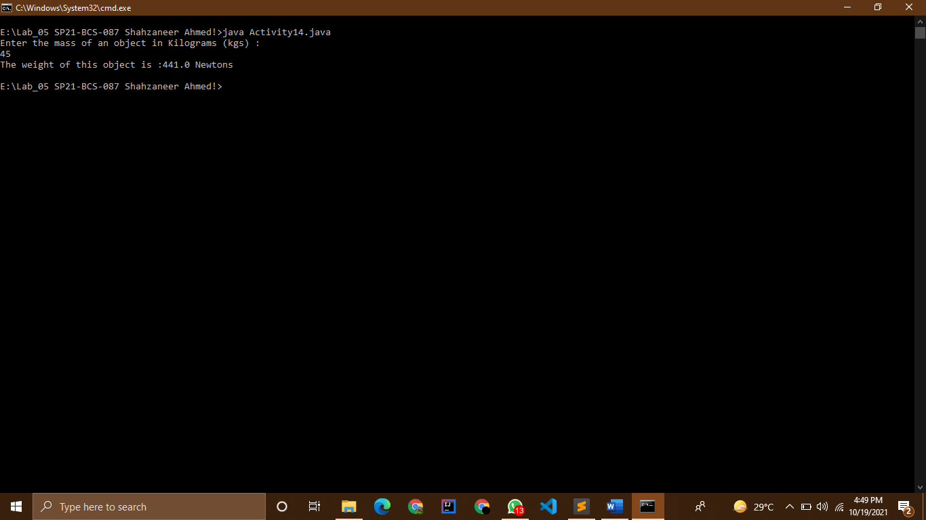

Activity 15

# Source Code :

//Shahzaneer Ahmed

//SP21-BCS-087

//LAB 04

//Activity-15

// Magic Dates

// The date June 10, 1960, is special because when it is written in the following format, the

// month times the day equals the year: 6/10/60

// Design a program that asks the user to enter a month (in numeric form), a day, and a

// two-digit year. The program should then determine whether the month times the day

// equals the year. If so, it should display a message saying the date is magic. Otherwise, it

// should display a message saying the date is not magic.

import java.util.Scanner;

public class Activity15 {

public static void main(String[] args) {

Scanner obj = new Scanner(System.in);

System.out.println("Enter Date in numeric format (dd/mm/yy)");

System.out.println("Enter Day :");

int day = obj.nextInt();

System.out.println("Enter month :");

int month = obj.nextInt();

System.out.println("Enter Year :");

int year = obj.nextInt();

if ((day>0 && day<=31) && (month>0 && month<=12) && (year>=0 && year<=99)){

if (day*month == year) System.out.printf("This is Magic date %d/%d/%d :" ,day,month,year);

else System.out.printf("Not a magic Date : %d/%d/%d" ,day,month,year);

}

else{

System.out.println("Invalid date format");

}

}

}

Screenshot :

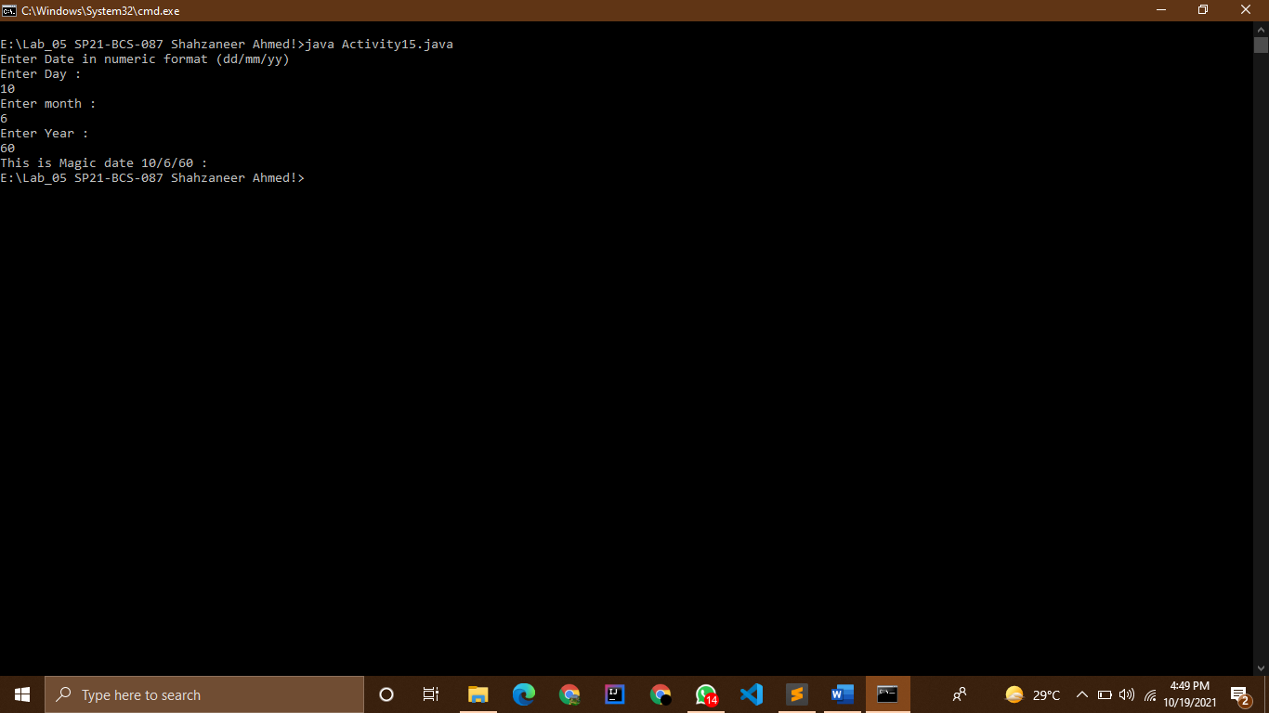

Activity 16

# Source Code :

//Shahzaneer Ahmed

//SP21-BCS-087

//LAB 04

//Activity-16

// Color Mixer

// The colors red, blue, and yellow are known as the primary colors because they cannot

// be made by mixing other colors. When you mix two primary colors, you get a secondary

// color, as shown here:

// When you mix red and blue, you get purple.

// When you mix red and yellow, you get orange.

// When you mix blue and yellow, you get green.

// Design a program that prompts the user to enter the names of two primary colors to

// mix. If the user enters anything other than “red,” “blue,” or “yellow,” the program

// should display an error message. Otherwise, the program should display the name of

// the secondary color that results

import java.util.Scanner;

public class Activity16 {

public static void main(String[] args) {

Scanner obj = new Scanner(System.in);

System.out.println("Enter two colors to mix among red , yellow and blue :");

System.out.println("Color 1 :");

String color1 = obj.next();

System.out.println("Color 2 :");

String color2 = obj.next();

if (color1.equals("red") && color2.equals("blue")) System.out.println(" Purple");

else if (color1.equals("blue") && color2.equals("red")) System.out.println(" Purple");

else if (color1.equals("red") && color2.equals("yellow")) System.out.println(" Orange");

else if (color1.equals("yellow") && color2.equals("red")) System.out.println(" Orange");

else if (color1.equals("blue") && color2.equals("yellow")) System.out.println(" Purple");

else if (color1.equals("yellow") && color2.equals("blue")) System.out.println(" Purple");

else System.out.println("error! please enter primary colors !!");

}

}

Screenshot : 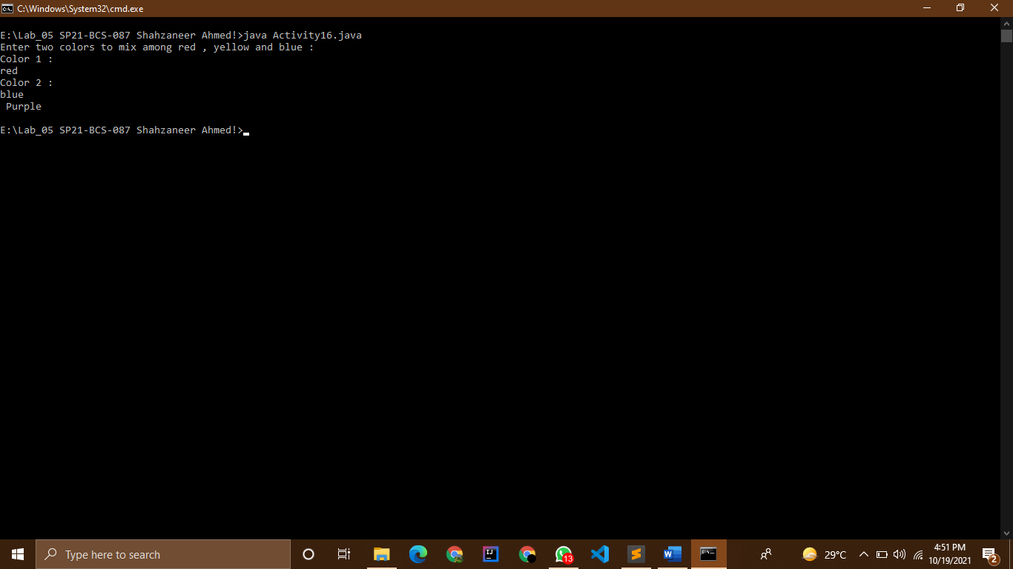

Activity 17

# Source Code :

//Shahzaneer Ahmed

//SP21-BCS-087

//LAB 04

//Activity-17

// Change for a Dollar Game

// Create a change-counting game that gets the user to enter the number of coins required

// to make exactly one dollar. The program should prompt the user to enter the number of

// pennies, nickels, dimes, and quarters. If the total value of the coins entered is equal to

// one dollar, the program should congratulate the user for winning the game. Otherwise,

// the program should display a message indicating whether the amount entered was

// more than or less than one dollar

import java.util.Scanner;

public class Activity17 {

public static void main(String[] args) {

// 100 pennies are a dollar

// 20 nickels are a dollar

// 10 dimes are a dollar

// 4 quarters are a dollar

Scanner obj = new Scanner(System.in);

System.out.print("Enter the number of Pennies:");

int pennies = obj.nextInt();

System.out.print("Enter the number of Nickels:");

int nickels = obj.nextInt();

System.out.print("Enter the number of Dimes:");

int dimes = obj.nextInt();

System.out.print("Enter the number of Quarters:");

int quarters = obj.nextInt();

int pennies_conversion = pennies/100; //converting no of pennies in dollars

int nikels_conversion = nickels/20; // ..........................nickels

int dimes_conversion = dimes/10; //............................dimes

int quarters_conversion = quarters/4; //.........................quarters

// now adding the total amount of dollar!

double dollar = (pennies_conversion+nikels_conversion+dimes_conversion+quarters_conversion);

// System.out.println(dollar); // used it for checking it

if(dollar == 1) System.out.println("Congratulations You Won a Dollar");

else if(dollar>1) System.out.println("Amount is more than a Dollar");

else if (dollar<1) System.out.println("Amount is less than a Dollar");

}

}

Screenshot : 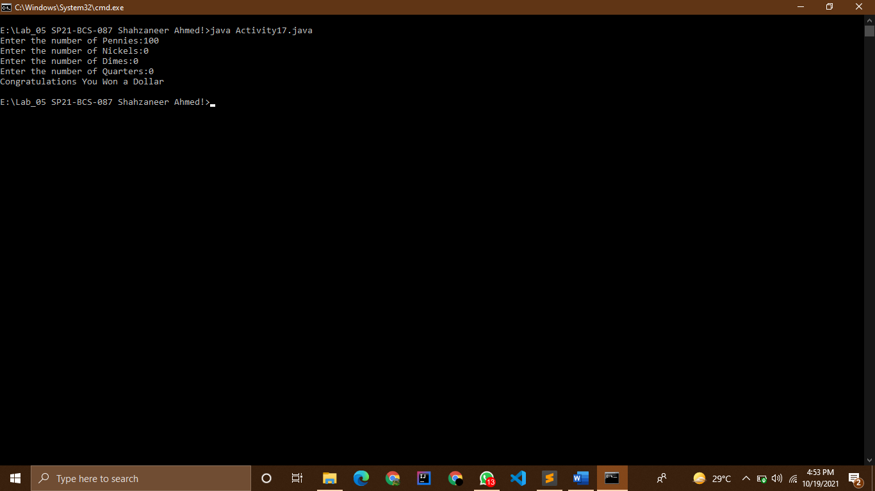

Activity 18

# Source Code :

//Shahzaneer Ahmed

//SP21-BCS-087

//LAB 04

//Activity-18

// Book Club Points

// Serendipity Booksellers has a book club that awards points to its customers based on

// the number of books purchased each month. The points are awarded as follows:

// • If a customer purchases 0 books, he or she earns 0 points.

// • If a customer purchases 1 book, he or she earns 5 points.

// • If a customer purchases 2 books, he or she earns 15 points.

// • If a customer purchases 3 books, he or she earns 30 points.

// • If a customer purchases 4 or more books, he or she earns 60 points.

// Write a program that asks the user to enter the number of books that he or she has

// purchased this month and displays the number of points awarded.

import java.util.Scanner;

public class Activity18 {

public static void main(String[] args) {

Scanner obj = new Scanner(System.in);

System.out.println("Enter the no of books purchased in a month :");

int bookPurchased = obj.nextInt();

if (bookPurchased==0) System.out.println("You earned 0 points !");

else if (bookPurchased==1) System.out.println("You earned 5 points !");

else if (bookPurchased==2) System.out.println("You earned 15 points !");

else if (bookPurchased==3) System.out.println("You earned 30 points !");

else if (bookPurchased>=4) System.out.println("You earned 60 points !");

}

}

Screenshot :

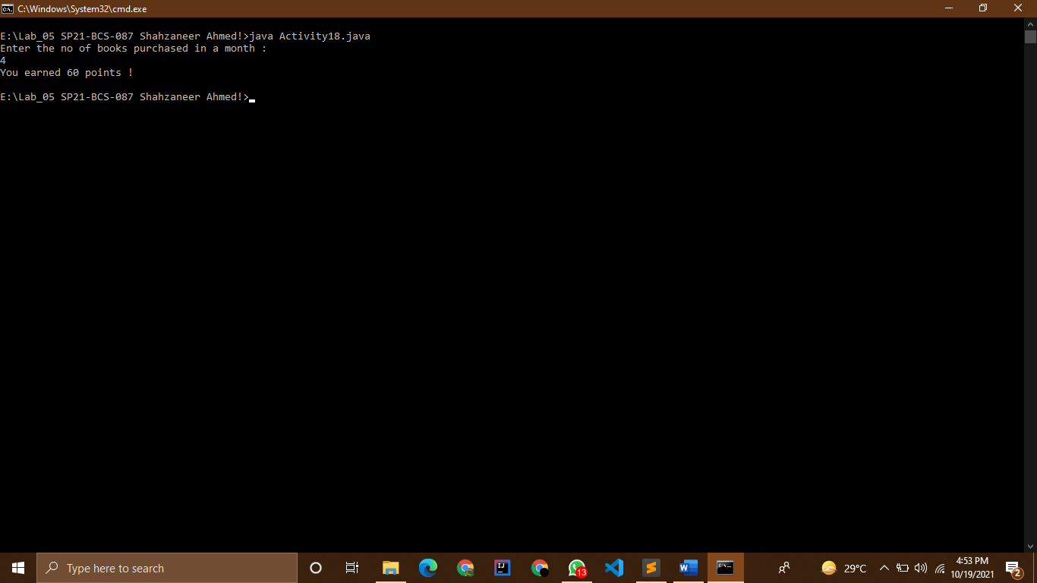

Activity 19

# Source Code :

//Shahzaneer Ahmed

//SP21-BCS-087

//LAB 04

//Activity-19

// Software Sales

// A software company sells a package that retails for $99. Quantity discounts are given

// according to the following table:

// Write a program that asks the user to enter the number of packages purchased. The

// program should then display the amount of the discount (if any) and the total amount of

// the purchase after the discount.

import java.util.Scanner;

public class Activity19 {

public static void main(String[] args) {

Scanner obj = new Scanner(System.in);

int packagePrice = 99;

System.out.println("Enter the no of packages purchased to get the amount of discount :");

int noPackages = obj.nextInt();

int originalAmount = packagePrice*noPackages;

double discountedAmount_20 = originalAmount-(originalAmount*0.2);

double discountedAmount_30 = originalAmount-(originalAmount*0.3);

double discountedAmount_40 = originalAmount-(originalAmount*0.4);

double discountedAmount_50 = originalAmount-(originalAmount*0.5);

if (noPackages<10) System.out.println("you have no Discount , your total amount for the packages is :"+originalAmount+"$");

else if (noPackages>=10 && noPackages<=19)

System.out.println("You have 20% Discount , your total amount for the packages were :"+originalAmount +

"$ And the discounted amount is : "+discountedAmount_20+" $");

else if (noPackages>=20 && noPackages<=49)

System.out.println("You have 30% Discount , your total amount for the packages were :"+originalAmount +

"$ And the discounted amount is : "+discountedAmount_30+" $");

else if (noPackages>=50 && noPackages<=99)

System.out.println("You have 40% Discount , your total amount for the packages were :"+originalAmount +

"$ And the discounted amount is : "+discountedAmount_40+" $");

else if (noPackages>100)

System.out.println("You have 50% Discount , your total amount for the packages were :"+originalAmount +

"$ And the discounted amount is : "+discountedAmount_50+" $");

}

}

Screenshot :

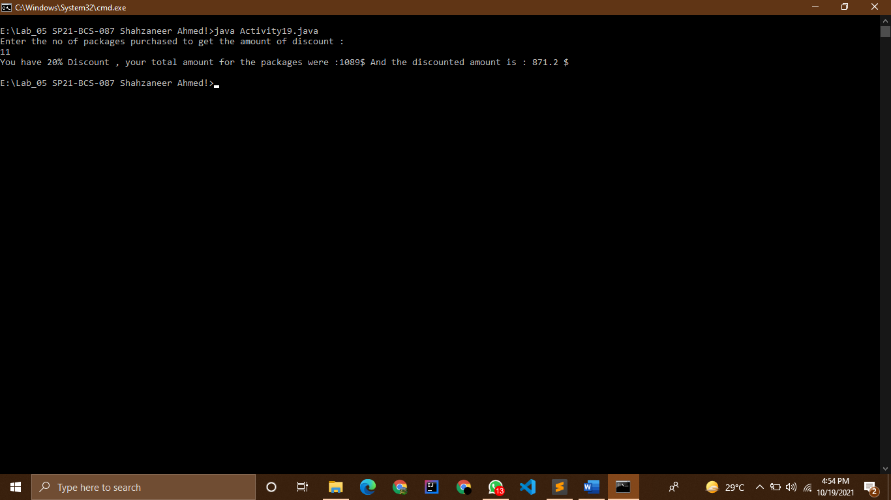

Activity 20

# Source Code :

//Shahzaneer Ahmed

//SP21-BCS-087

//LAB 04

//Activity-20

// Shipping Charges

// The Fast Freight Shipping Company charges the following rates:

// Write a program that asks the user to enter the weight of a package and then displays

// the shipping charges

import java.util.Scanner;

public class Activity20 {

public static void main(String[] args) {

Scanner obj = new Scanner(System.in);

System.out.println("Enter the weight of Shipping object in pounds :");

float weight = obj.nextFloat();

if (weight<=2) System.out.println("The shipping charges are $1.10");

if (weight>2 && weight<=6) System.out.println("The shipping charges are $2.20");

if (weight>6 && weight<=10) System.out.println("The shipping charges are $3.70");

if (weight>10) System.out.println("The shipping charges are $3.80");

}

}

Screenshot :

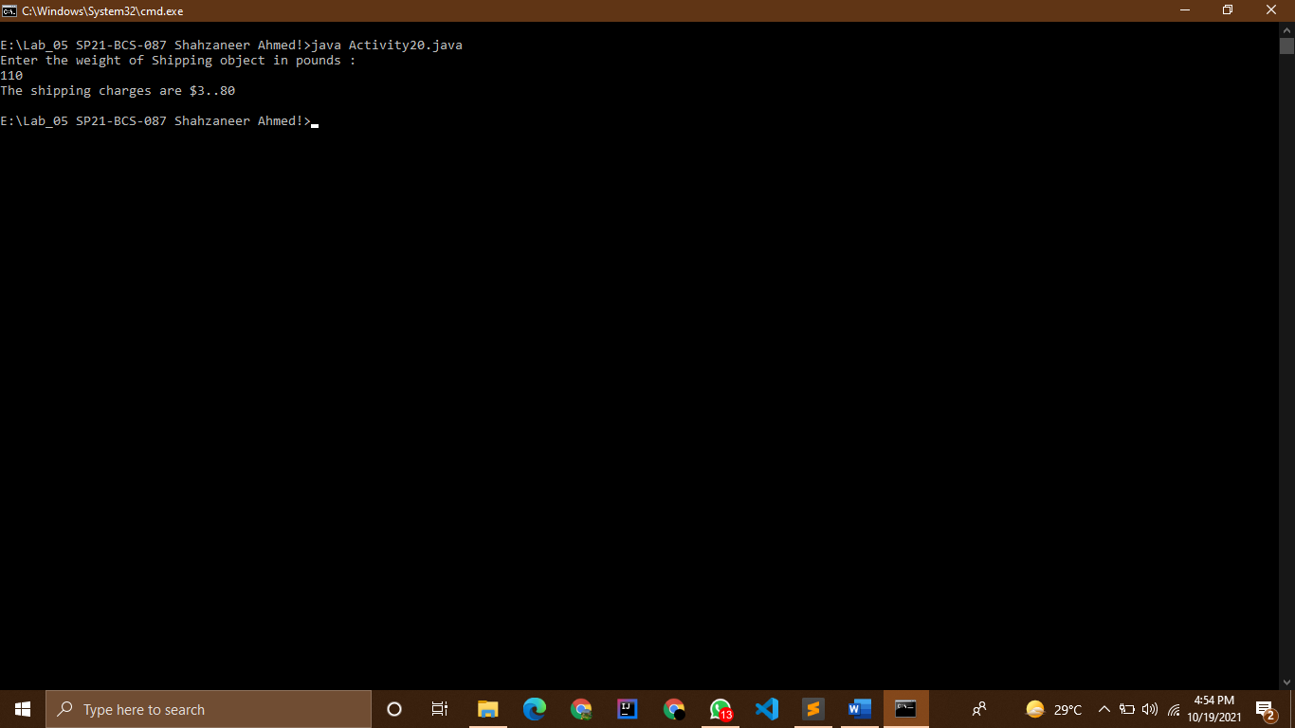

Activity 21

# Source Code :

//Shahzaneer Ahmed

//SP21-BCS-087

//LAB 04

//Activity-21

// Body Mass Index Program Enhancement

// The BMI is often used to determine whether a person is overweight or underweight for

// their height. A person’s BMI is calculated with the formula

// BMI= weight x 703 / height2

// Where weight is measured in pounds and height is measured in inches. Write a program

// that displays a message indicating whether the person has optimal weight, is

// underweight, or is overweight. A person’s weight is considered to be optimal if his or

// her BMI is between 18.5 and 25. If the BMI is less than 18.5, the person is considered to

// be underweight. If the BMI value is greater than 25, the person is considered to be

// overweight.

import java.util.Scanner;

public class Activity21 {

public static void main(String[] args) {

Scanner obj = new Scanner(System.in);

float height,weight;

System.out.println("Enter your Height in inches :");

height = obj.nextFloat();

System.out.println("Enter your weight in pounds :");

weight = obj.nextFloat();

float bmi = (weight*703)/(height*height);

if (bmi<18.5) System.out.println("You are Underweight ");

else if (bmi>=18.5 && bmi<=25) System.out.println("You are optimal weight ");

else if (bmi>25) System.out.println("You are overweight ");

}

}

Screenshot :

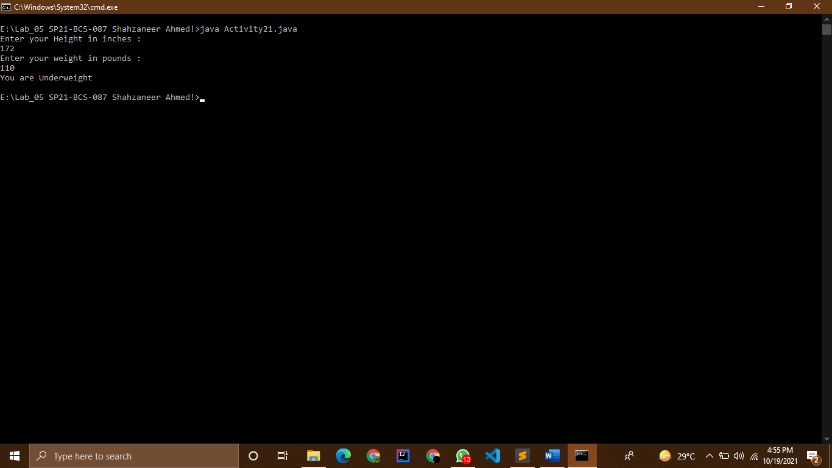

Activity 22

# Source Code :

//Shahzaneer Ahmed

//SP21-BCS-087

//LAB 04

//Activity-22

// Time Calculator

// Write a program that asks the user to enter a number of seconds, and works as follows:

// • There are 60 seconds in a minute. If the number of seconds entered by the user

// is greater than or equal to 60, the program should display the number of minutes

// in that many seconds.

// • There are 3,600 seconds in an hour. If the number of seconds entered by the

// user is greater than or equal to 3,600, the program should display the number of

// hours in that many seconds.

// There are 86,400 seconds in a day. If the number of seconds entered by the user is

// greater than or equal to 86,400, the program should display the number of days in that

// many seconds

import java.util.Scanner;

public class Activity22 {

public static void main(String[] args) {

Scanner obj = new Scanner(System.in);

System.out.println("Enter the no of Seconds :");

int seconds = obj.nextInt();

float minutes = seconds/60;

float hours = seconds/3600;

float days = seconds/86400;

if (seconds<60)

System.out.println("it equals "+seconds +" Seconds ");

else if (seconds>=60 && seconds<3600)

System.out.println("it equals "+minutes +" minutes");

else if (seconds>=3600 && seconds<86400)

System.out.println("it equals "+hours +" hours ");

else if (seconds>=86400)

System.out.println("it equals "+days +" days ");

}

}

Screenshot : 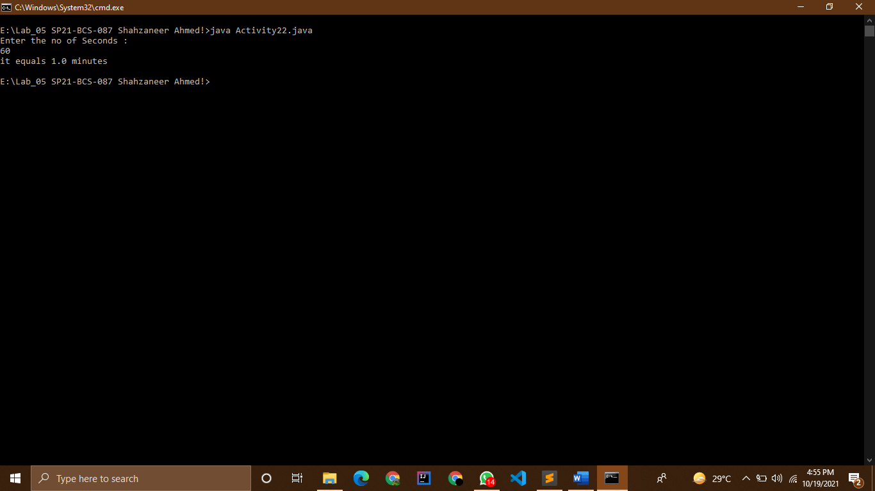

Activity 12

# Switch Statement

# Source Code :

//Shahzaneer Ahmed

//SP21-BCS-087

//LAB 04

//Activity-12

// Roman Numerals

// Write a program that prompts the user to enter a number within the range of 1 through

// 10. The program should display the Roman numeral version of that number. If the

// number is outside the range of 1 through 10, the program should display an error

// message. The following table shows the Roman numerals for the numbers 1 through 10

import java.util.Scanner;

public class Activity12Switch {

public static void main(String[] args) {

Scanner obj = new Scanner(System.in);

System.out.println("Enter any number between 1 to 10 ");

int num = obj.nextInt();

switch (num) {

case 1:

System.out.println("I");

break;

case 2:

System.out.println("II");

break;

case 3:

System.out.println("III");

break;

case 4:

System.out.println("IV");

break;

case 5:

System.out.println("V");

break;

case 6:

System.out.println("VI");

break;

case 7:

System.out.println("VII");

break;

case 8:

System.out.println("VIII");

break;

case 9:

System.out.println("IX");

break;

case 10:

System.out.println("X");

break;

default:

// if non case is followed then it will be followed!

System.out.println("Error!! please Enter any number only in between 1 and 10 ");

}

}

}

Screenshot :

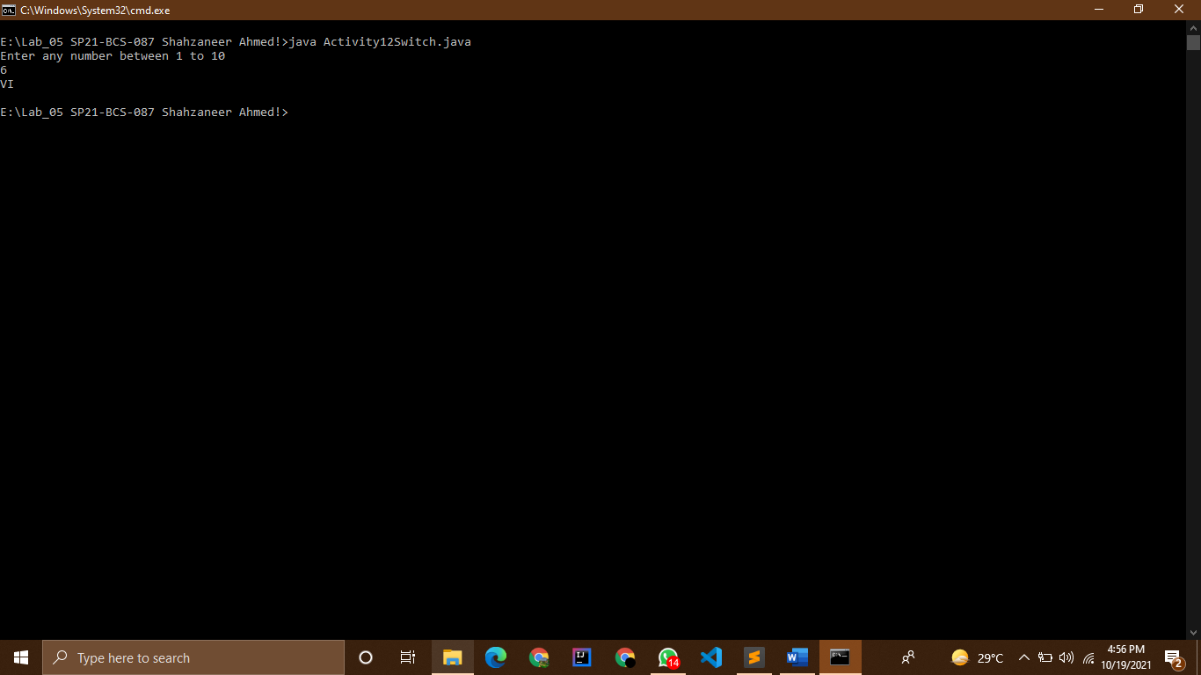

Activity 18

# Switch Statement

# Source Code :

//Shahzaneer Ahmed

//SP21-BCS-087

//LAB 04

//Activity-18

// Book Club Points

// Serendipity Booksellers has a book club that awards points to its customers based on

// the number of books purchased each month. The points are awarded as follows:

// • If a customer purchases 0 books, he or she earns 0 points.

// • If a customer purchases 1 book, he or she earns 5 points.

// • If a customer purchases 2 books, he or she earns 15 points.

// • If a customer purchases 3 books, he or she earns 30 points.

// • If a customer purchases 4 or more books, he or she earns 60 points.

// Write a program that asks the user to enter the number of books that he or she has

// purchased this month and displays the number of points awarded.

import java.util.Scanner;

public class Activity18Switch {

public static void main(String[] args) {

Scanner obj = new Scanner(System.in);

System.out.println("Enter the no of books purchased in a month :");

int bookPurchased = obj.nextInt();

switch (bookPurchased) {

case 0: System.out.println("You earned 0 points !");

break;

case 1: System.out.println("You earned 5 points !");

break;

case 2: System.out.println("You earned 15 points !");

break;

case 3: System.out.println("You earned 30 points !");

break;

case 4: System.out.println("You earned 60 points !");

break;

// in case if more than 4 books are purchased!

default: System.out.println("You have earned 60 points !");

// the limitation of this program is that it works only when we give positive input

}

}

}

Screenshot : 